HTML is a markup language

HTML is used for presentation of data and providing UI for client/end User. It provides the user interface for accessing web resources.

HTML is used for creating web pages.

HTML provides tokens and these are called tags. Each tag represents one element.

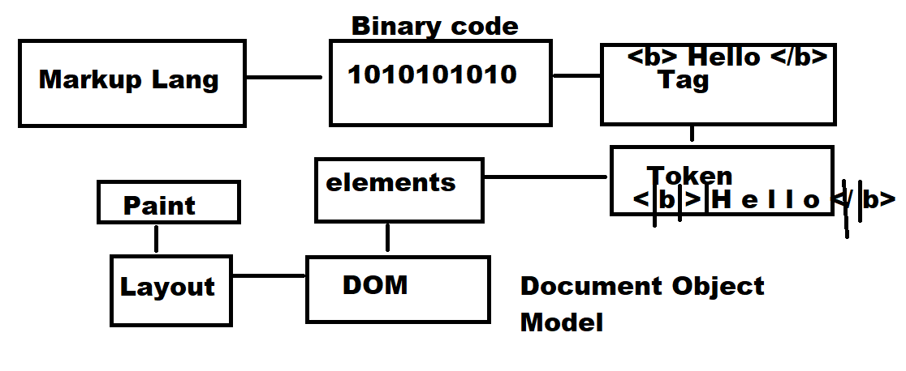

**HTML elements are classified into 5 groups**

1. Normal elements
2. Empty elements/void elements
3. RC Data Elements
4. Raw Text Elements
5. Foreign Elements

**Normal elements**

An element which presents data without using any attributes.

This element required begins token/tag/element and end token/tag/element.

Normal elements return values

Example: <b>…</b>

**Empty elements/void elements**

Void elements required attributes to present data.

It does not return any value/data

Void elements do not have end tag/token

Example: <img>

**RC Data elements**

RC Data elements are called Rich Text Data elements.

These elements are used to represent plain text, numbers and other content.

RC data elements/tag does not allow nested tags/elements.

Example: <textarea> … </textarea>

**Raw text elements**

Raw text elements are presented using raw text; it does not required any tags.

**Example:**

&copy;

Amount   &nbsp;&nbsp;&nbsp;&nbsp;&nbsp;&nbsp;  is &#8377 45,000/-

**Foreign Elements**

These elements are not comes default with HTML.

These elements are available in library.

Library must be imported in order to use.

**Example: Canvas**

**Web Page**

Every page or html page is having extension .html or .htm

**Note:** tools can be used for creating web page

Example if web page is created using ms-word, this page is saved with .htm

1. **Define Document Definition/Declaration**

Document definition tells the browser which language and version is used to develop webpage

This document definition is given using <!DOCTYPE html>

If HTML page is written in HTML 5.0, doctype is must.

<!DOCTYPE *html*>

codewithsatishgupta

pythonbygupta@gmail.com